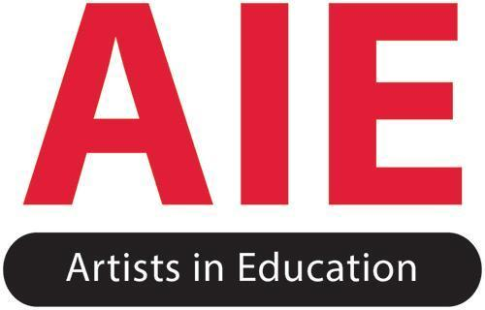

Artists in Education Grant
Grants to Districts and Province-Wide School Associations
2023-24 Guidelines

The Artists in Education (AIE) grants support artistic programming, including performances, workshops, and residencies to empower young people in schools across the province. AIE is funded by the B.C. Arts Council and the Province of British Columbia as a district-level grant allocated to all B.C. School Districts, the Federation of Independent School Associations and the First Nations Schools Association.

Grant Outcomes for Students, Artists, and Educators.
- Introduce young people to arts-based workshops, performances, and residencies with educational impact.
- Facilitate communication between the arts and education communities by developing mutual awareness, respect and appreciation of arts-based learning.
- Establish professional standards for arts practices and presentations in schools.

Grant Objectives for Students, Artists, and Educators.
- Promote the arts as an area of study and professional employment to young people.
- Co-develop opportunities for artists to work with young people and educators.
- Support for artists to perform in unique contexts such as remote and rural communities.
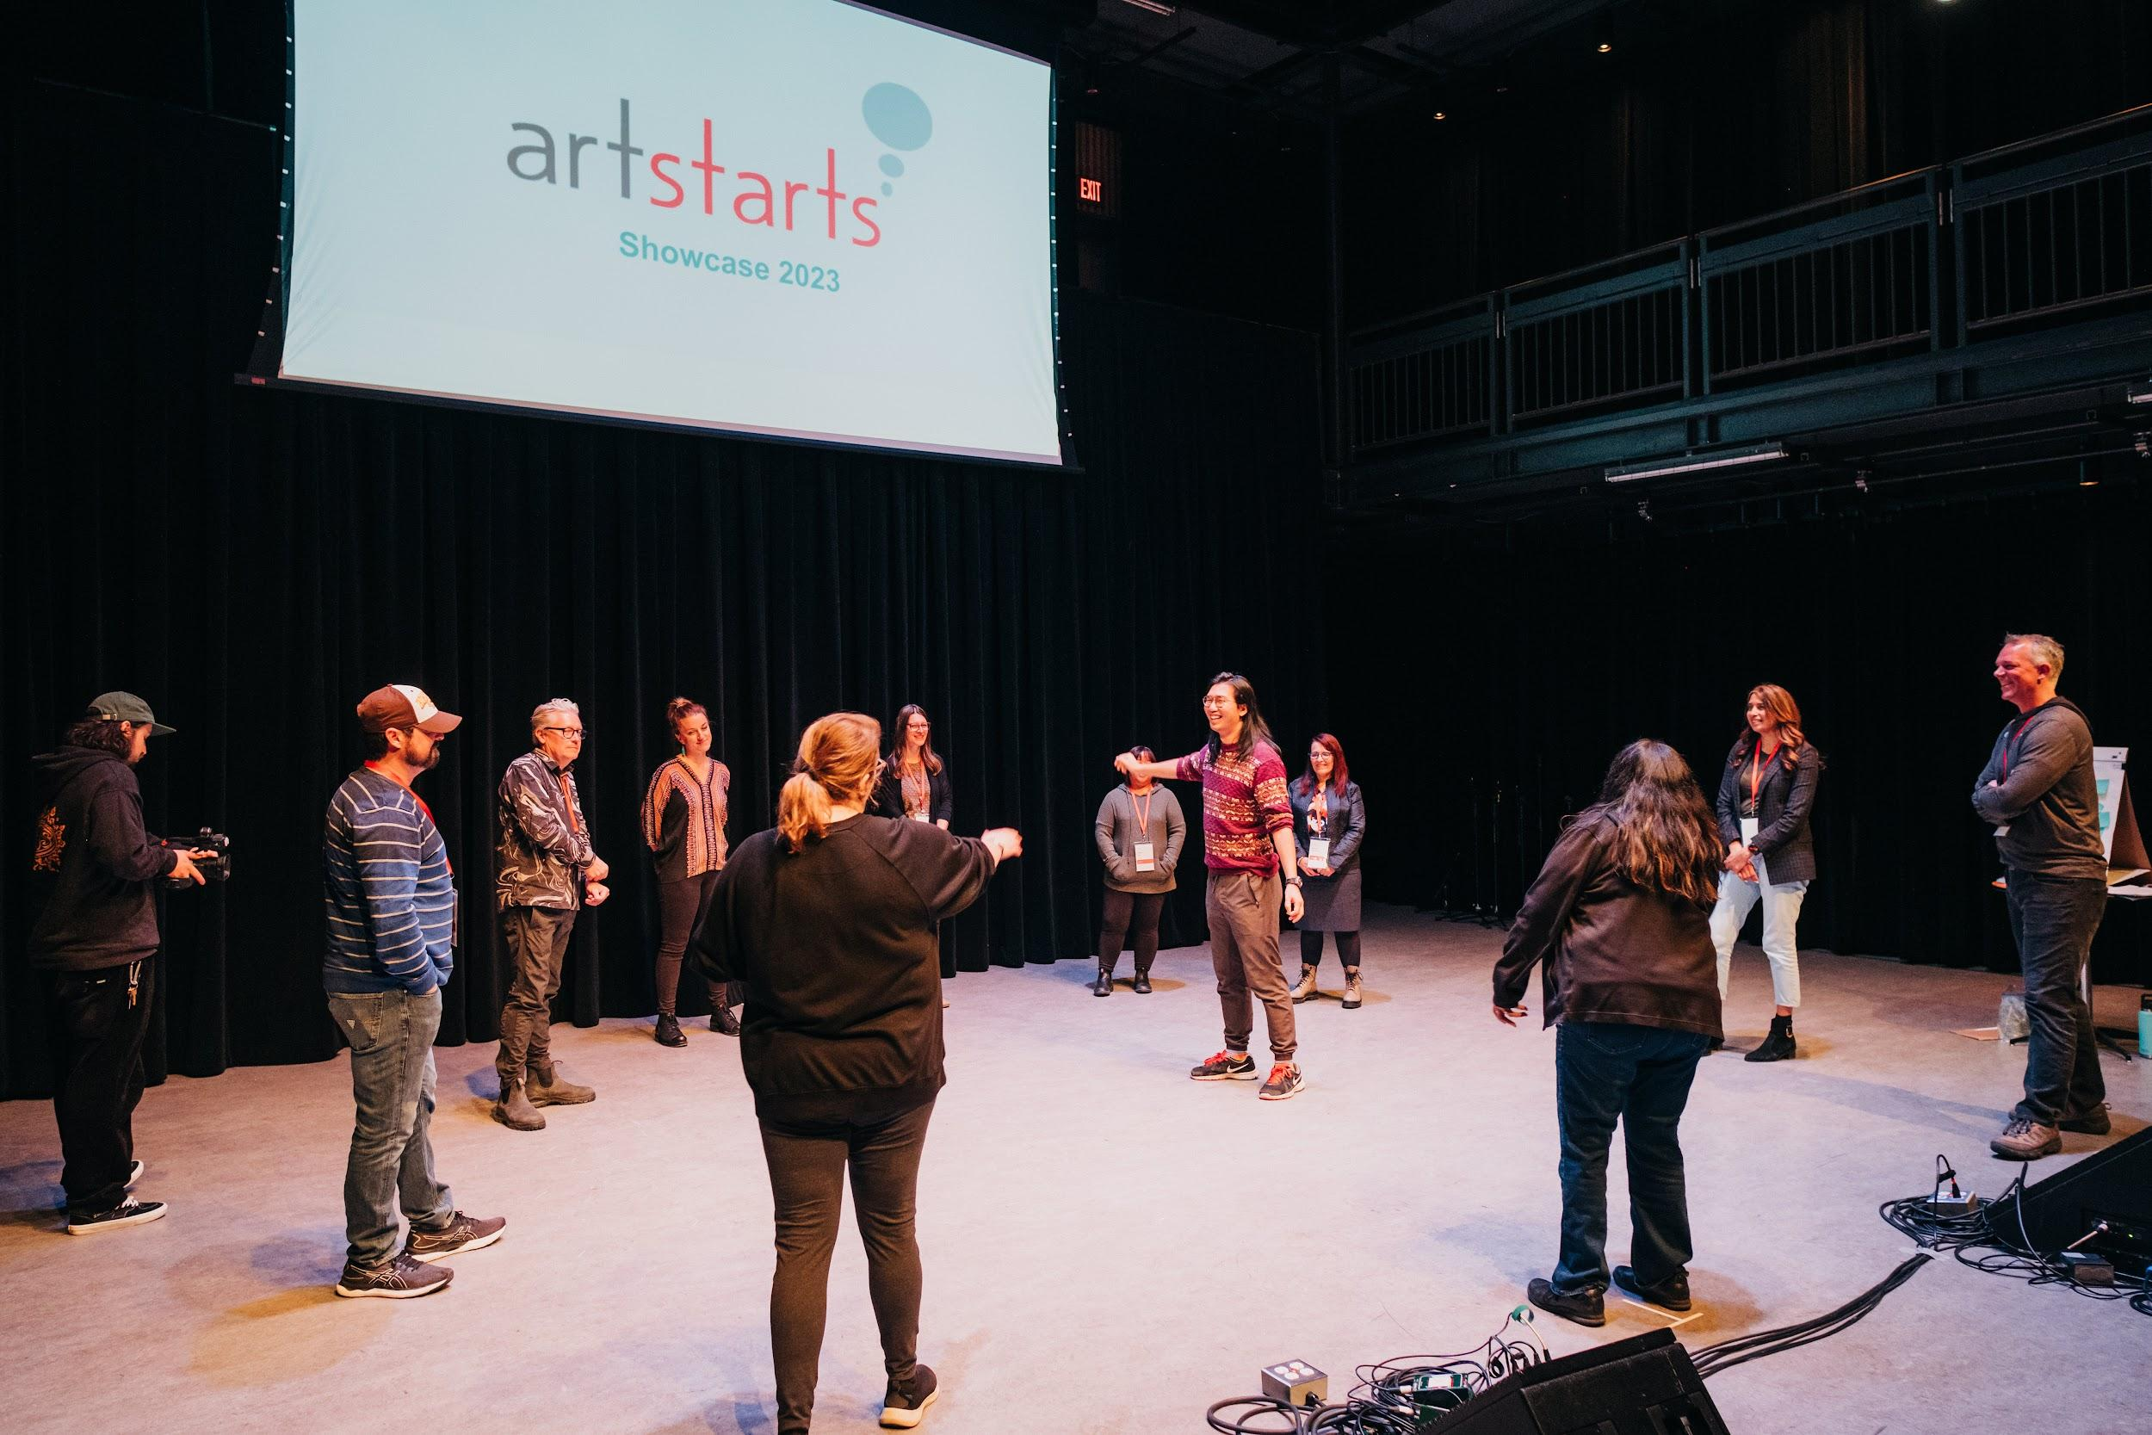

Grant Criteria and Standards
Applicants can use grant funds towards professional artist fees for school performances, workshops, and residencies. Arts activities may encompass the performing, visual, media, and literary arts. All arts activities must demonstrate a thoughtful approach to local cultural contexts, potential for educational impact and be delivered in meaningful partnership with arts organizations and/or artists.

Granting Criteria
- Applying organization must be a B.C. School District, the Federation of Independent School Associations or the First Nations Schools Association
- Individual schools, daycares, colleges and universities are not eligible to apply
- Applicants must meet all reporting requirements to receive their maximum funding allocation

Granting Standards
- Applicant funds must be equitably distributed for thoughtful access across geographic contexts and other relevant factors within the district or association. The district should determine and share what equity looks like for their region.
- Grant application must demonstrate how proposed arts activities take place in a school and are for the benefit of young people in Grades K – 12
- All AIE funds are to be spent in the school year granted

Each allocation considers the number of schools, number of students and geographic location of each district or association. All AIE funds are guaranteed year to year for each district and school association provided that all expenses are eligible and you have completed the Final Report form for the previous year you received AIE Funds.

Eligible Expenses

Any expenses not explicitly listed as eligible are considered ineligible. If you have questions about budget eligibility, please email us at aie@artstarts.com.

Professional Artist Fees

70% for B.C. based artists; 40% for out-of-province artists within Canada.
The FNSA District may cover up to 90% of artist fees for B.C. based artists; 40% for out-of-province artists within Canada

Transportation Expenses for Remote Areas

Grant Applications can cover up to 50% of transportation expenses for artists travelling to schools and up to 50% for students travelling to arts events in remote areas.
Transportation expenses cannot exceed more than 25% of the total AIE grant allocation.
The following districts may cover up to 100% of transportation expenses: FNSA, School District 49 - Central Coast, School District 81 - Fort Nelson, School District 84 - Vancouver Island West, School District 87 - Stikine
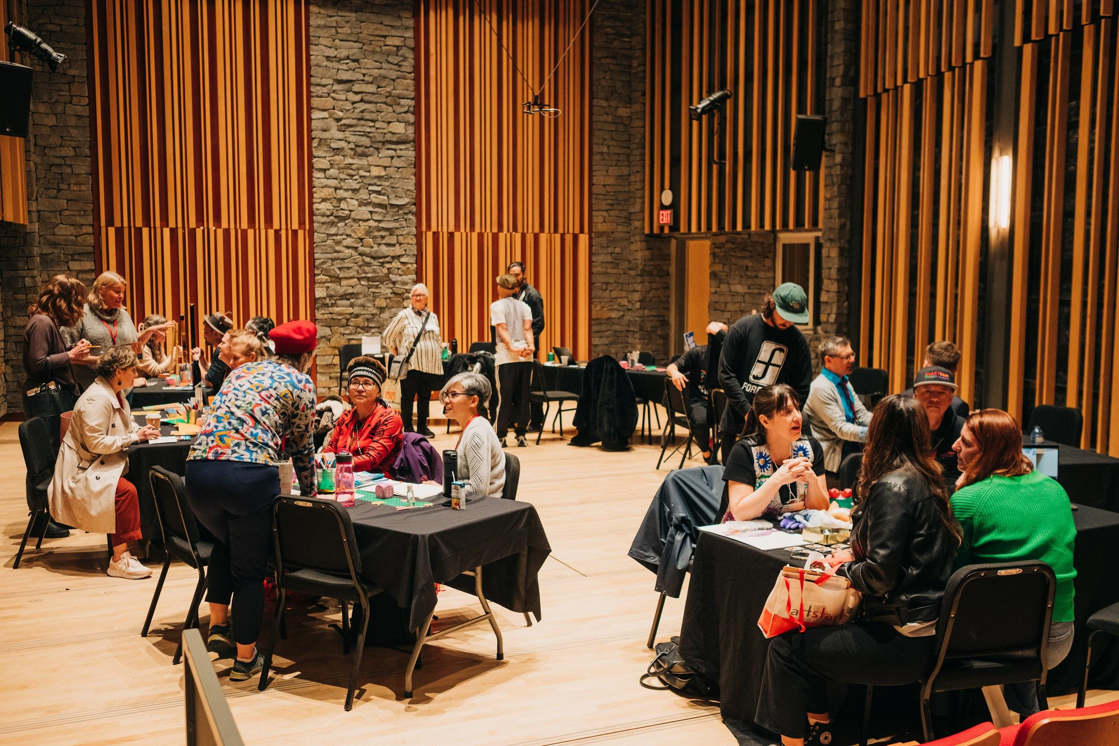
Conference and Showcase Attendance
To support schools and districts in finding artists that are eligible for coverage under the AIE Grant to work with at their school, the AIE Grant covers fees to attend any BC Based Artist Showcase. We cover up to 100% of conference fees, travel, and accommodation to attend any BC-based Arts and Culture Showcase, including ArtStarts Showcase and Pacific Contact.

Please contact us at aie@artstarts.com if you have any questions about using funds for Conference and Showcase Attendance

Ineligible Expenses
- Fees for artists residing outside of Canada
- Non-professional artists (including established youth companies)
- Students attending events outside of school hours that require single ticket purchases for each student or where admission fees are charged
- School assemblies with non-arts based motivational speakers and novelty acts
- Administrative/staff time required to manage the program
- GST/PST

Grant Guidelines

Considering Cultural Context and Safety

All applicants should consider the issues around cultural appropriation if artists they are selecting are using the cultural forms, aesthetics or iconography of cultural communities removed from their social, political and cultural roots. Cultural appropriation can also occur when there is insufficient credit given to the sources of artistic and cultural work. Cultural appropriation can cause harm to Indigenous and diverse communities through misrepresentation and stereotyping. It diminishes access and reduces the opportunity for artists from Indigenous and diverse cultural communities to tell their own stories.

When considering which artists and arts experiences to submit with this application, please take cultural safety and appropriation seriously to ensure that students are thoughtfully engaging with traditional knowledge and stories in context. The revised BC curriculum offers an approach that we support:

“It is particularly helpful to co-operate and engage with experts from the community when learning about culture-specific contexts to avoid offence or misrepresentation or appropriation of culture. Cultural appropriation includes use of cultural motifs, themes, “voices,” images, knowledge, stories, songs, drama, and so on without permission or without appropriate context or in a way that may misrepresent the real experience of the people from whose culture they are drawn.”

If you are seeking further clarification on cultural context and safety, we encourage you to reference ArtStarts in Schools’ Anti-Oppression Guidelines. We are grateful for the learnings from our friends at Inner Activist, PeerNet, SOGI 123 and Tierra Negra.

Considering Indigenous People, Lands, Contexts and Safety

If artists are working with Indigenous peoples, communities, culture or intellectual property (including but not limited to stories, songs, dance, designs, art, traditional knowledge or other cultural expressions), applications should express how their proposed project considers and respects the the principles outlined in the United Nations Declaration of the Rights of Indigenous Peoples (the Declaration). The Declaration affirms that Indigenous peoples have the right to self-determination and the right to practice and revive their culture and traditions. As stated in Article 11 of the Declaration,

“This includes the right to maintain, protect and develop the past, present and future manifestations of their cultures, such as archaeological and historical sites, artefacts, designs, ceremonies, technologies and visual and performing arts and literature.”

Article 31 of the Declaration affirms the rights of Indigenous peoples to maintain, control, protect and develop their cultural heritage, traditional knowledge and cultural expressions and their manifestations and intellectual property. If you are working with traditional knowledge, you will need to explain how you have addressed cultural protocols and/or received permissions where required. Additional guidance and resources can be found at https://www.indigenousprotocols.art/

Recognition And Compensation Guidelines for Professional Artist or Arts Organization

AIE grants are intended to be responsive to community contexts and have the power to make a transformational and powerful impact on students, educators, and artists. Successful AIE applications must recognize appropriate cultural ownership protocols, compensate artists fairly, and celebrate cultural traditions in respectful and informed ways.

Artist Recognition
All Canadian professional artists are eligible to be funded through AIE. ArtStarts maintains a directory of professional artists. If you are considering professional artists outside the directory please consider the Canada Council's definition of a professional artist below.

Definition of Professional Artist from Canada Council for the Arts
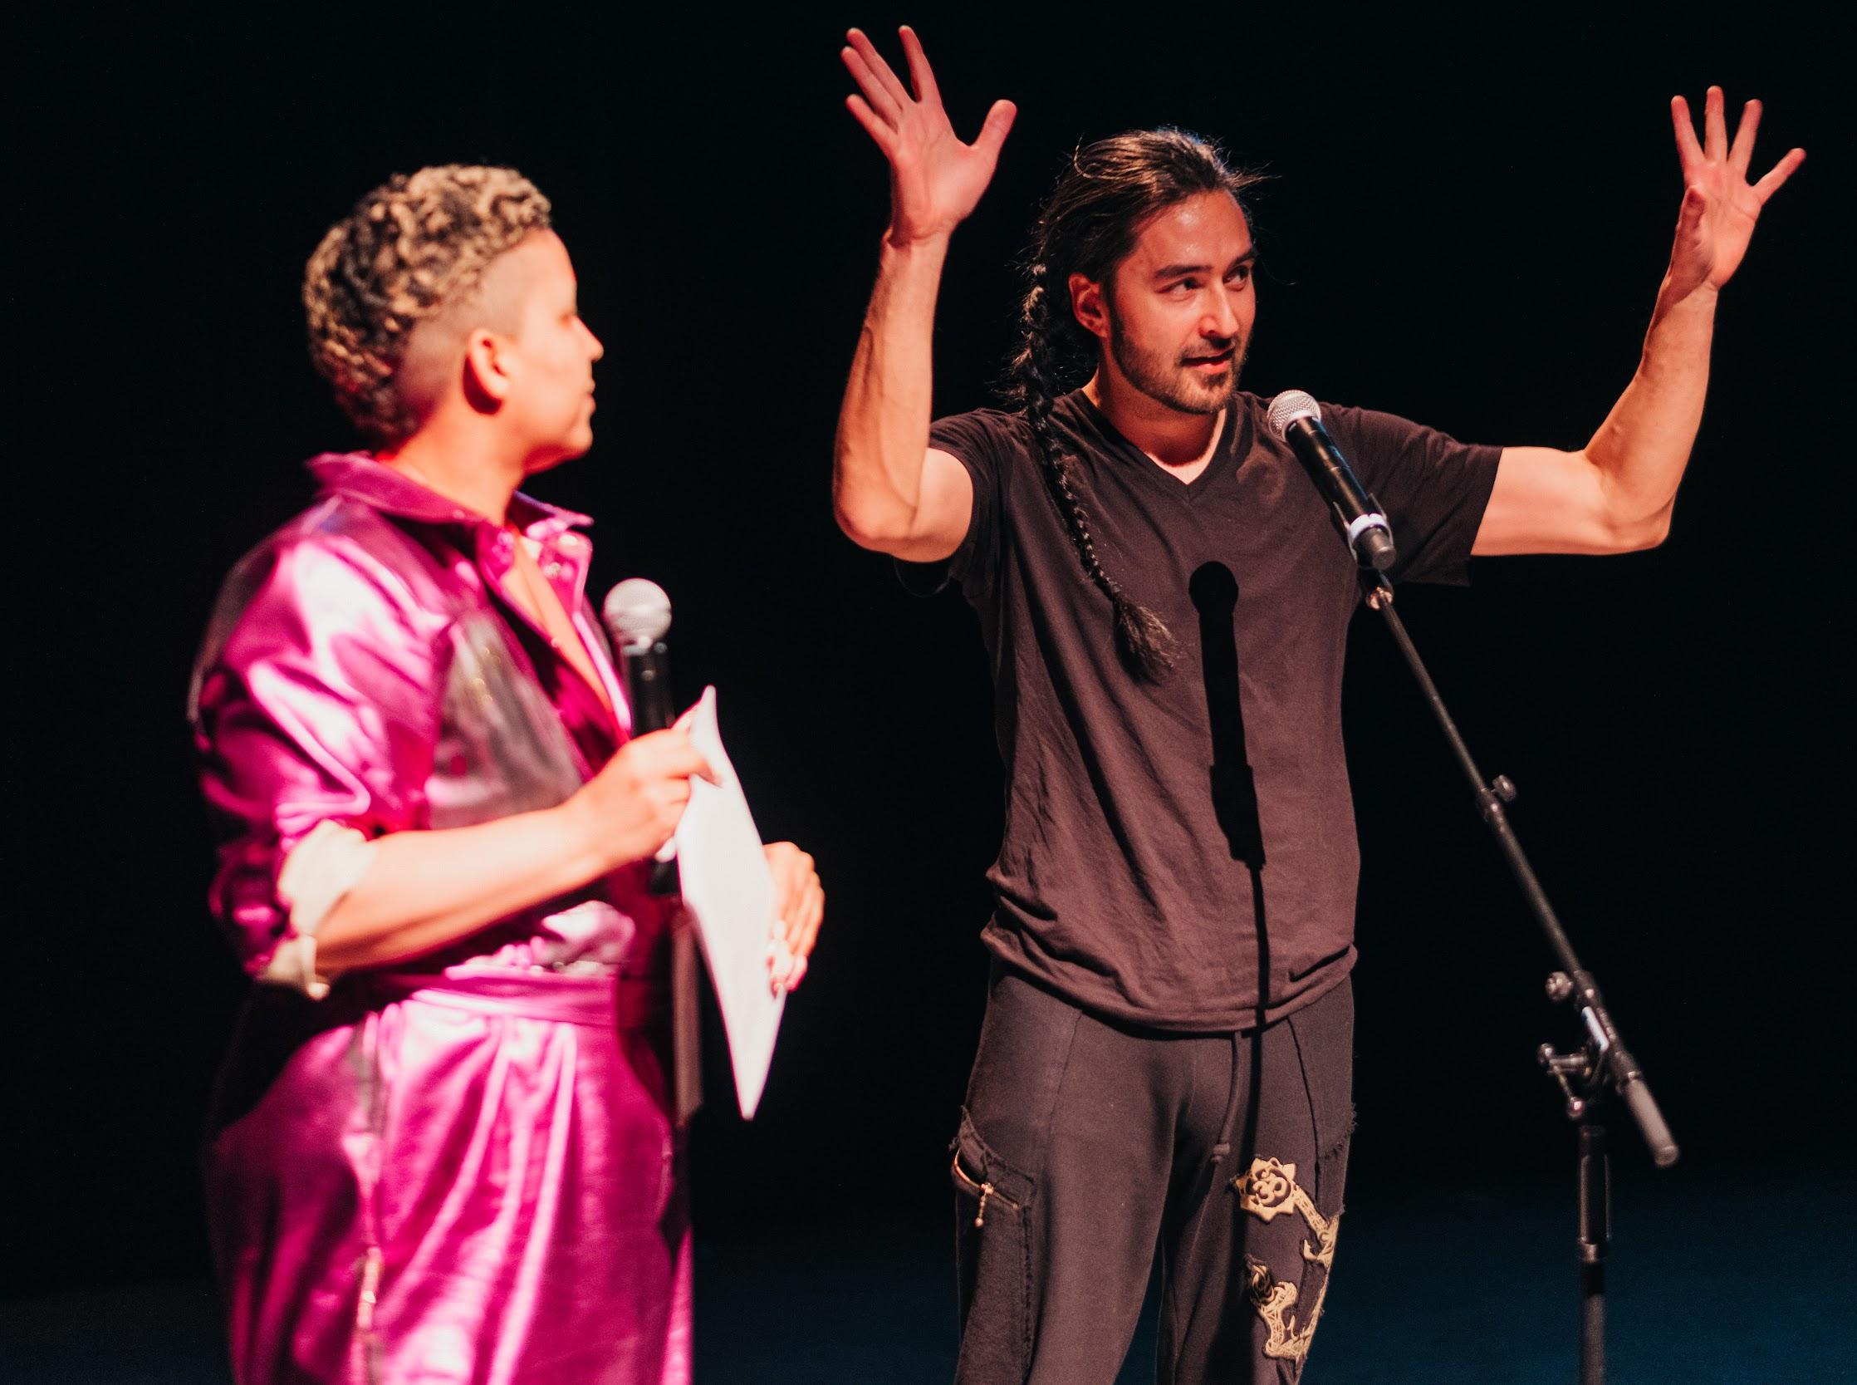
A professional artist is defined as someone who:
- has specialized training in the artistic field (not necessarily in academic institutions);
- is recognized as a professional by their peers (artists working in the same artistic tradition);
- is committed to devoting more time to artistic activity, if possible financially; and
- has a history of public presentation or publication.

Further to the above definition, Indigenous Elders, Traditional Knowledge Keepers, and other artists with Indigenous or other culturally traditional arts practices fall under the definition of professional artists.

If you have questions if an artist or arts organization is an appropriate fit for the AIE grant, please contact aie@artstarts.com.

CV Transcription Service: ArtStarts offers a CV transcription service for artists, Indigenous Elders, Knowledge Keepers, and other artists with Indigenous art practices. This service is intended to reduce barriers for artists who do not have a CV and/or may not see themselves in the definition of a professional artist. ArtStarts staff will talk to the artist and transcribe their artistic practice and experience into a written document that can be submitted with the grant as a CV.

Please contact ArtStarts at aie@artstarts.com to arrange the service prior to submitting your application.

Compensation
Please ensure to recognize and compensate artists and cultural practitioners fairly. The AIE grants support artists and arts organizations to thrive professionally in BC. Compensation should also be comparable to artists in the same field of practice and industry standards and adhere to international intellectual property rights standards. Resources on compensation can be found at CARFAC.

Submission Process

AIE Final Report for 2022 - 2023 activities - due by September 19th 2023*
* Please note, this is only applicable to districts who applied for the 2022-23 AIE Application

AIE Application for 2023 – 2024 activities - due by September 19th 2023

Update: There is only one form that contains both the Final Report Form and the Application Form. You or someone at your district has been emailed a unique link. Please email aie@artstarts.com if you do not have the link.

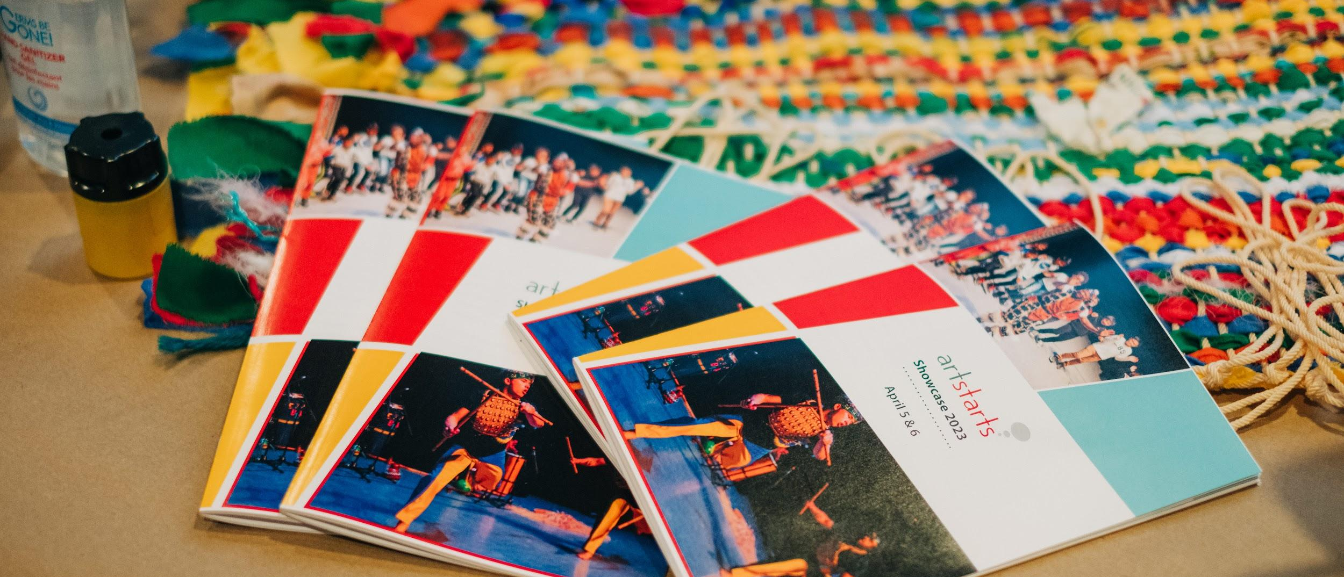

Application Steps

Step 1: Open the AIE Final Report and Application Form link that will be emailed to you. Your link is unique to your Final Report and Application and there is only one form to complete. Email aie@artstarts.com if you do not have the link.

Step 2: Complete the AIE Final Report section for the 2022-2023 School Year reporting on how the funds were spent for the year. If you did not apply for AIE for the 2022-23 Year, you do not need to complete a final report. Email aie@artstarts.com if you need information on performances or workshops that you booked through ArtStarts.

Step 3: Ensure you complete the Artist Information Spreadsheet for the 2022-23 Final Report. To do this, navigate to this link or you can download from the Final Report Google Form. Complete the form and submit the Final Report through the Google Form. The Final Report Spreadsheet has blue headings.

Step 4: If you have funds left unspent from the 2022-23 School Year, please check in with us at aie@artstarts.com before submitting your 2023-24 Application.

Step 5: Complete your 2023-24 Application through the unique link sent to your email. Look ahead to see which artists you may want to work with and think about how you will allocate funds to the schools in your district.

Step 6: Ensure you complete the Artist Information Spreadsheet for the 2023-24 Application. To do this, navigate to this link or you can download from the Application Google Form. Complete the form and submit the Application through the Google Form. The Application Spreadsheet has green headings.

Confirmations and Acceptance.
You will receive a confirmation of email shortly after submitting your application. If you haven't received a confirmation email by the end of September, please contact AIE@artstarts.com. ArtStarts Staff will contact you if there are changes or questions about your application or Final Report.

ArtStarts Staff meet with BC Arts Council Representatives to review allocations in November 2023 to review the allocations for the 2023-24 School Year. You will receive notice of the success of your grant by the end of the 2023 calendar year. ArtStarts Staff will send out the grant cheque by the end of February 2024.
_________________________________________________________________________________________________

Questions? Please Contact ArtStarts at aie@artstarts.com

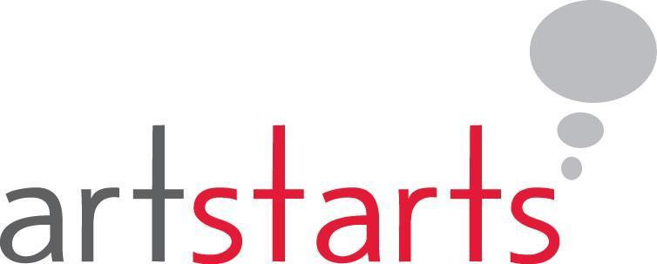

BC Arts Council and the Province of British Columbia are committed to ensuring that all British Columbians are able to participate in a healthy arts and cultural community recognized for its excellence. Through this provincial financial support, the arts and cultural community will continue to achieve its creative, social and economic success.

ArtStarts in Schools is a catalyst in promoting arts and creativity among B.C.’s young people. Working with a dynamic province-wide network of educators, artists, parents, students, schools and communities, ArtStarts provides innovative arts programs for young people, practical resources for teachers and artists, and leadership in advocacy for arts in education.

